**AWS and DevOps- Automated Docker Configuration via Docker Hub and GitHub in AWS**

1. Connect Docker Hub with Git Hub.
2. Login to Docker Hub
3. Account Setting
4. Link Account
5. Click on Connect for GitHub

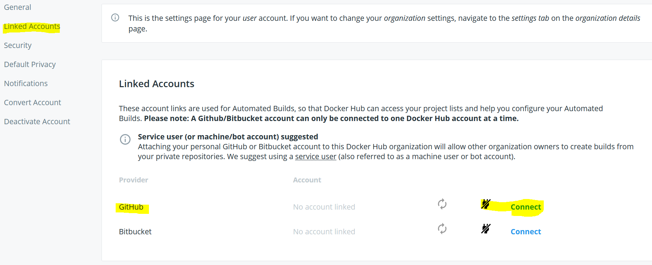

1. Click on Authorize Docker

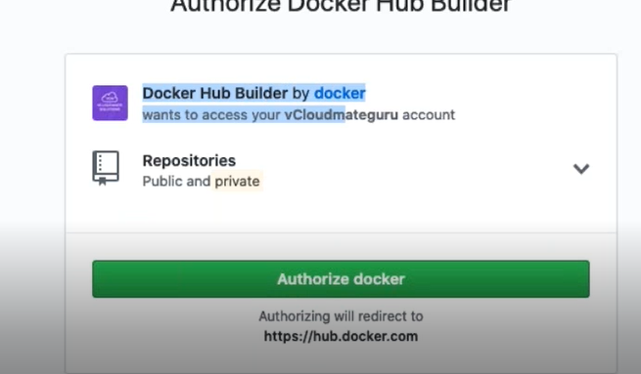

Now, we can observe Git account is linked to Docker hub.

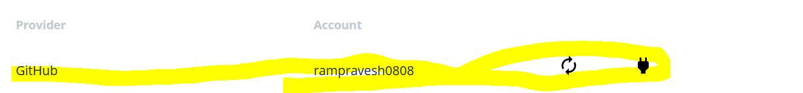

1. Now, create new repository in Docker Hub for Automated Repository Hub.

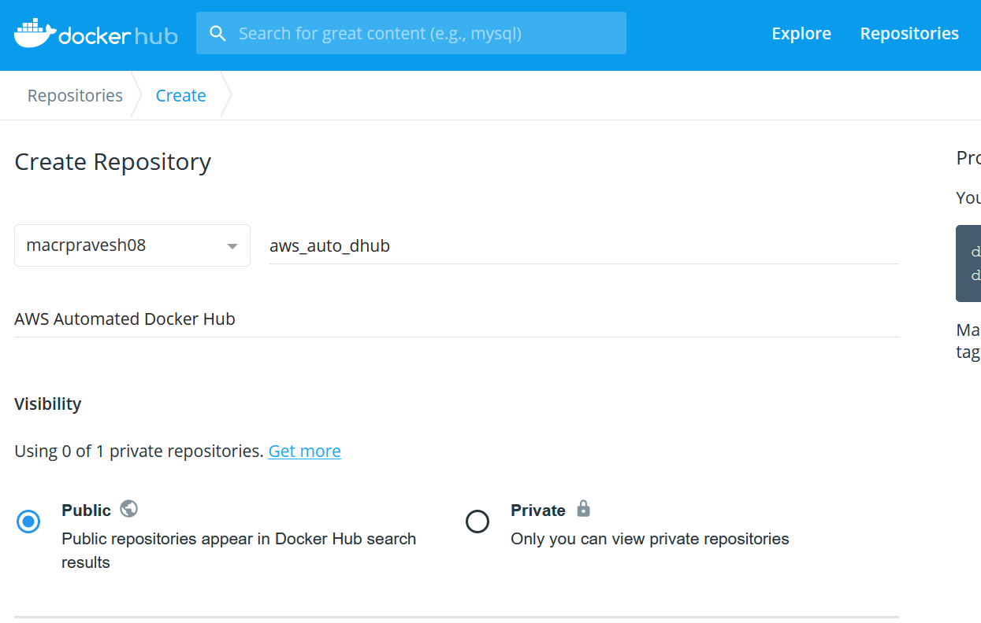

Now, Click on Connect, Select Git Acount Name and DockerDemoApp Project git repository name.

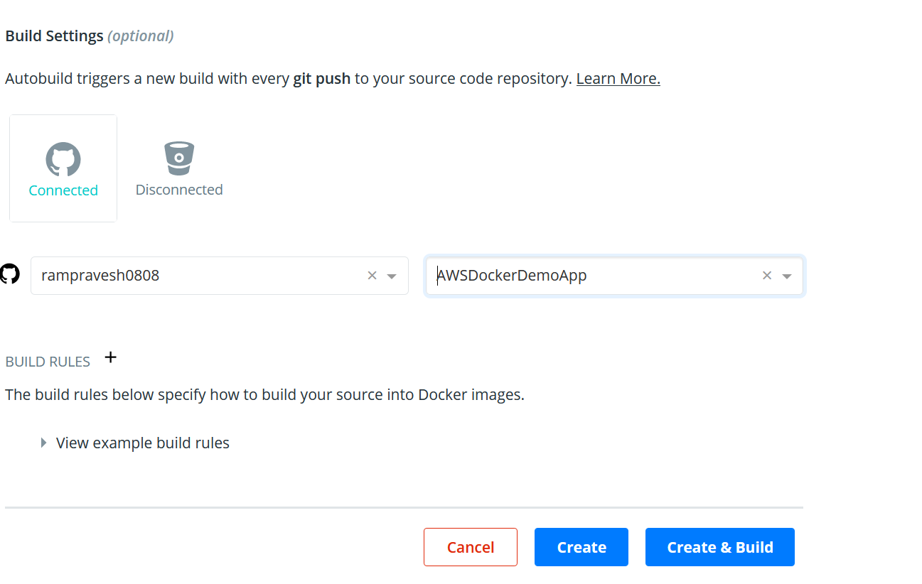

Click on Create & Build Button.

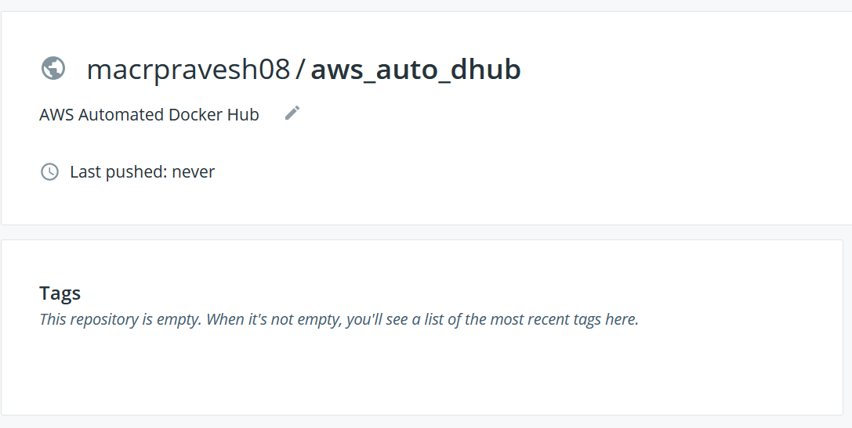

Now, Go to Build Tab in docker hub account of newly created repo (aws_auto_hub)

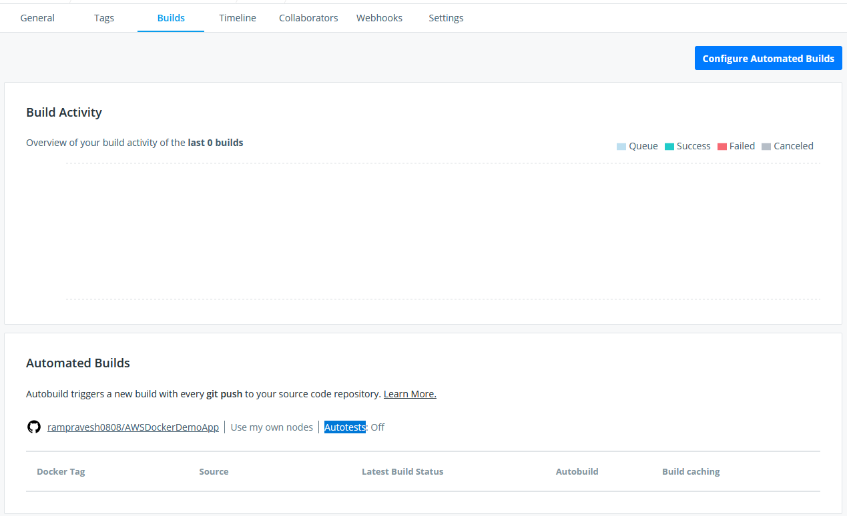

Now, Click on ‘Configure Automated Builds’

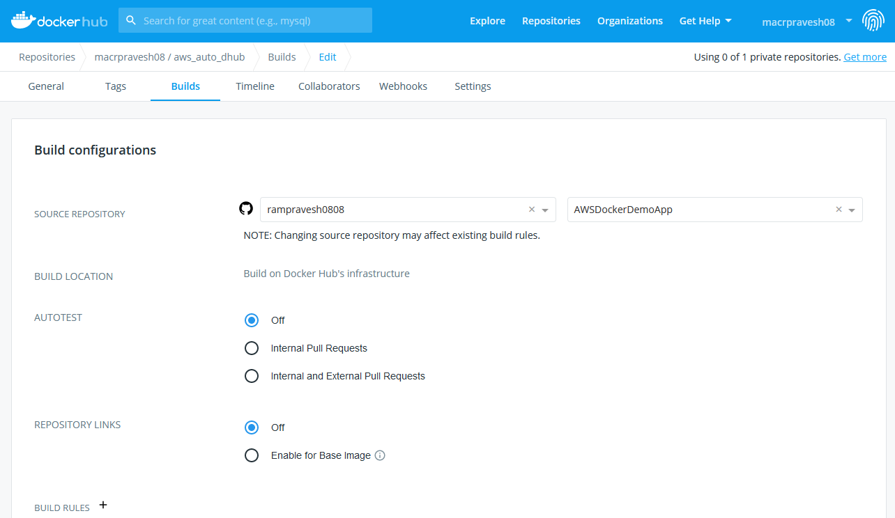

Add Rules

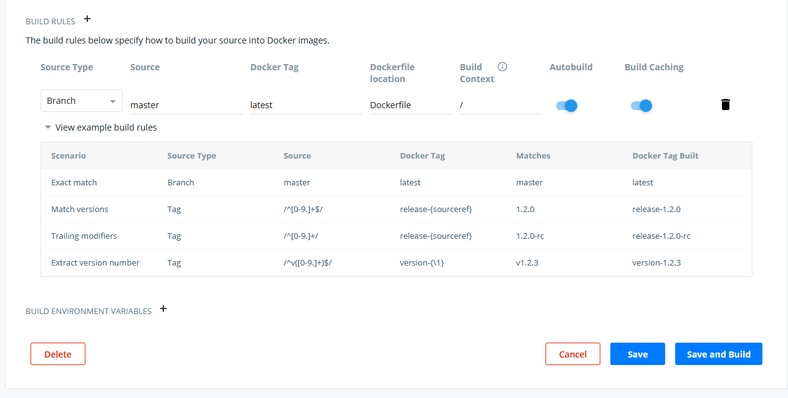

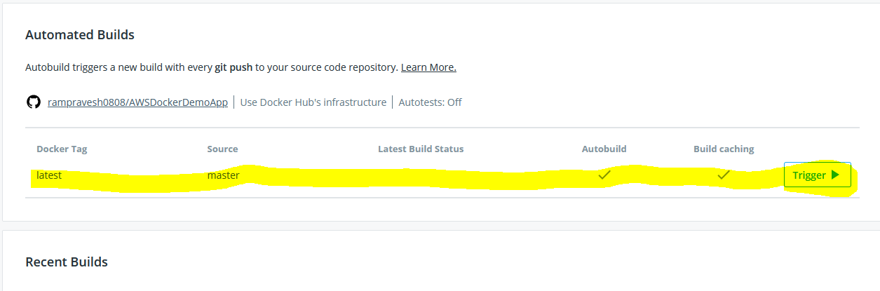

1. Pushed new changes in source code git repository.

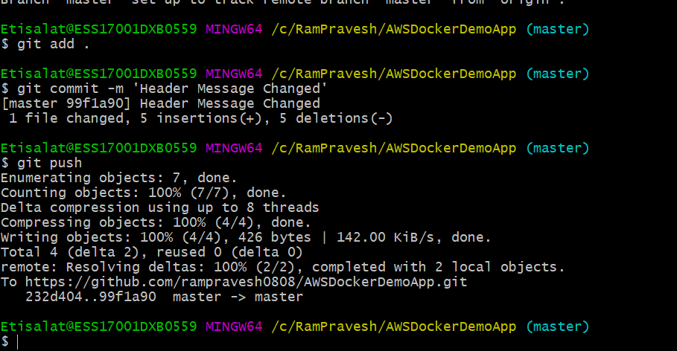

As per Auto build rules (Auto build triggers a new build with every git push to your source code repository),

Go to Docker Hub and observed that a new build has been triggered.

Latest build status is ‘PENDING’, wait for sometime.

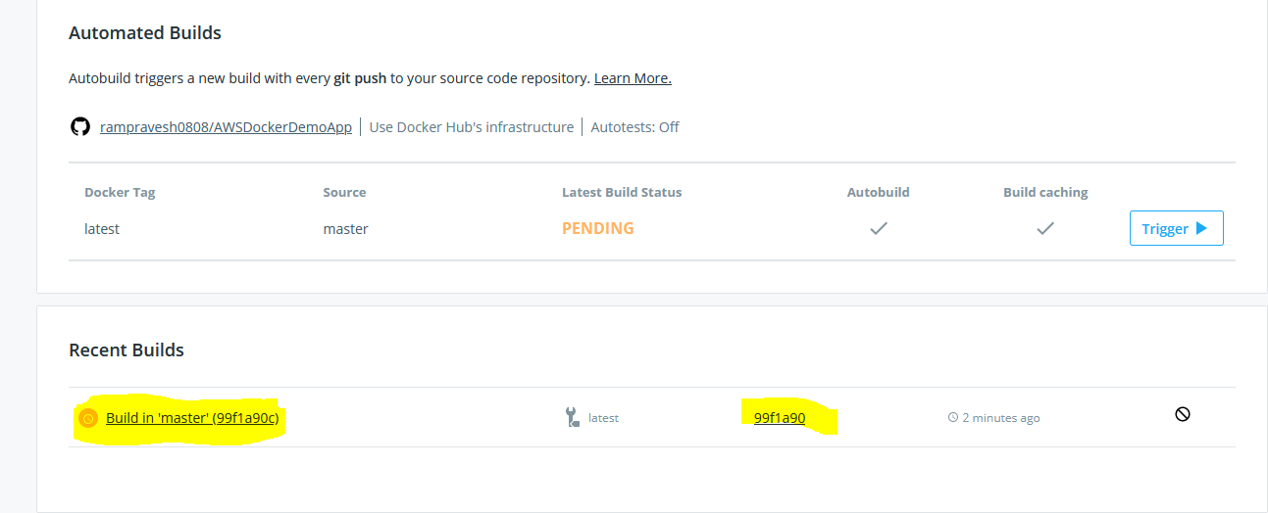

Now, Latest Build Status is success’

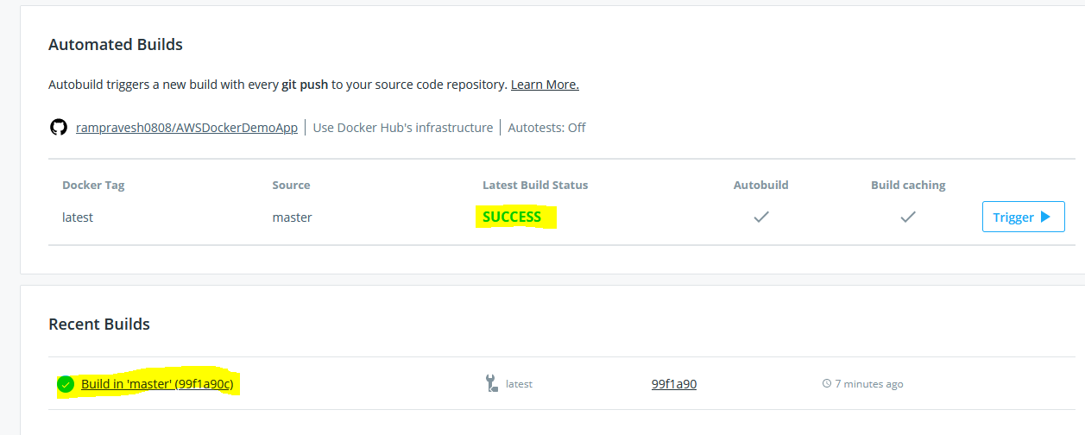

You can observe build log for more details…..

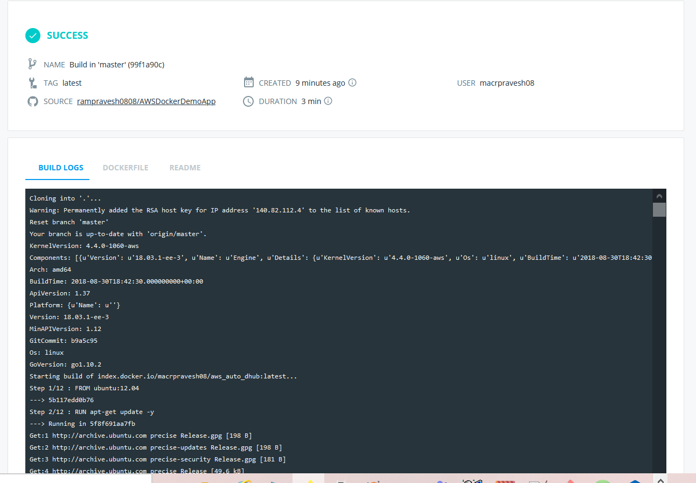

1. Provision EC2 machine using Amazon Linux AMI for Dockers Server.

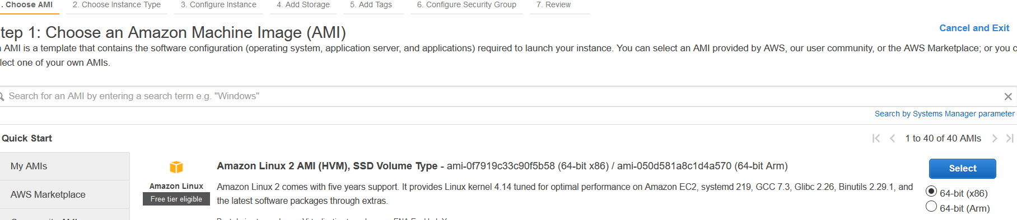

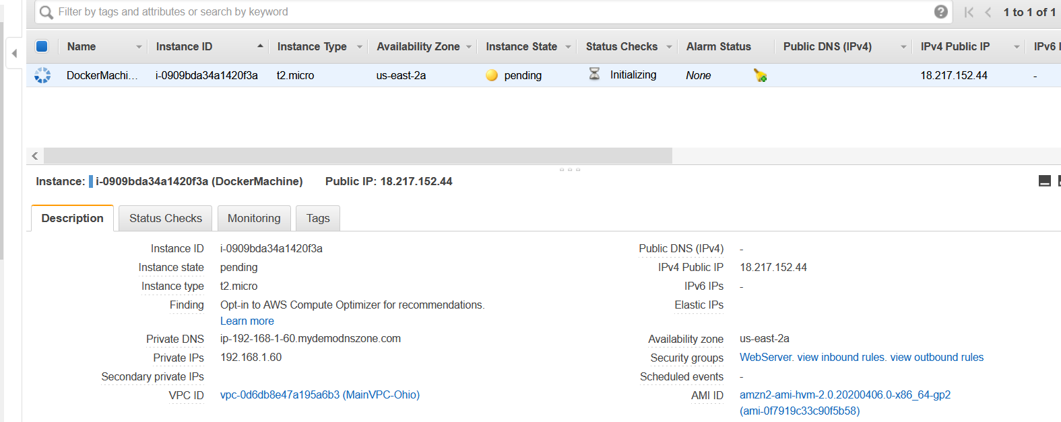

1. Now connect and login to Docker Machine.

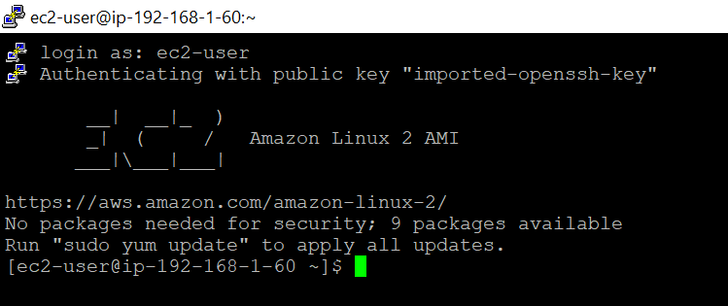

1. Take the root privilege.

Sudo su

Cd

1. Install the docker, since OS on docker machine is Amazon Linux so we will using ‘**yum’ command.**

**Yum update -y**

**Yum install docker**

**Check docker information: docker info**

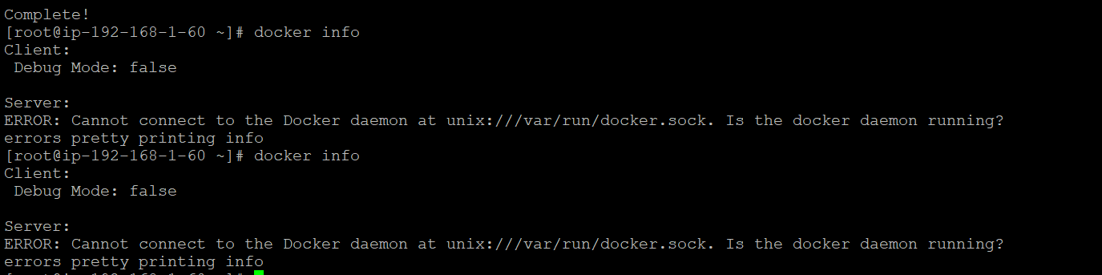

Start the docker daemon: **service docker start**

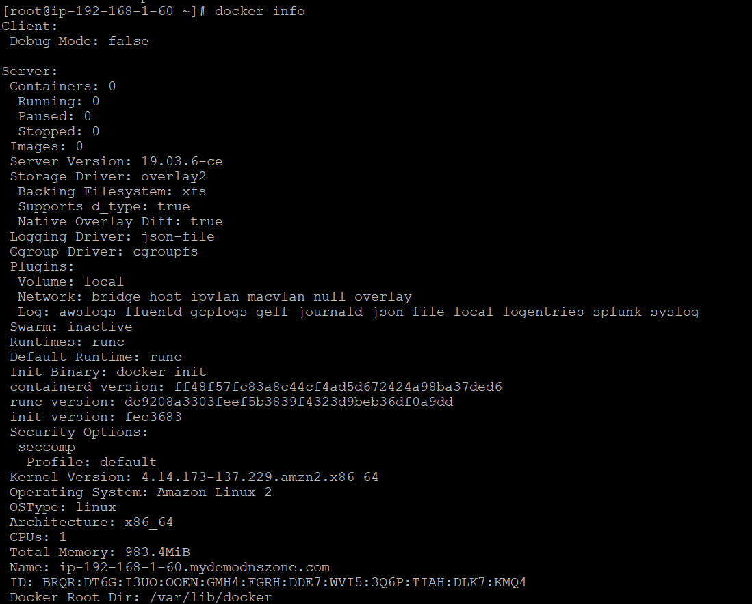

**Now, we can observer docker is installed and running.**

1. Now, Pull the docker image form docker hub(**macrpravesh08/aws_auto_dhub**) and run below command-

**docker pull macrpravesh08/aws_auto_dhub:latest**

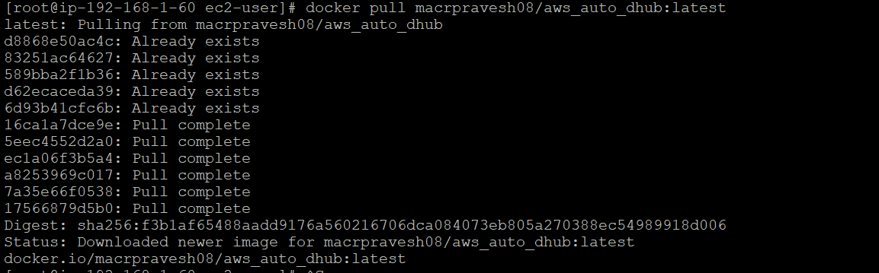

Run Below command –

**docker run -p 80:80 macrpravesh08/aws_auto_dhub:latest**

Observed error : Bind for 0.0.0.0:80 failed: port is already allocated.

Hence, killed the current docker running deamon

**docker kill blissful_pasteur**

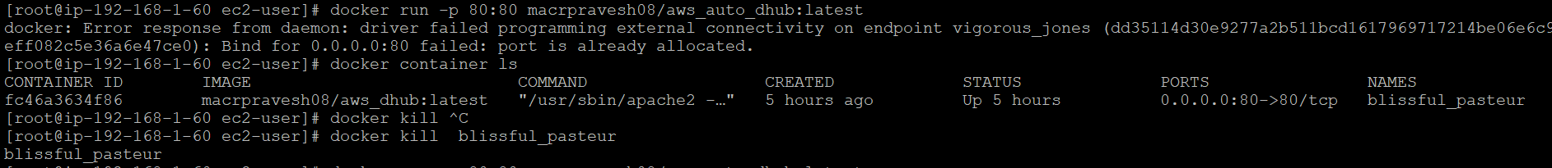

Now Finally Run the image –

**docker run -p 80:80 macrpravesh08/aws_auto_dhub:latest**



